Stat 301 – Lab 4
Goals:
Be able to read data correctly when not in the default format expected by JMP.
Analyze two group studies:
with 2 independent samples (mouse weight study)
or with paired data (reading study).

We will use the mouse weight (mousewt.txt) and paired reading scores (pairedscores.txt) data to repeat the calculations shown in lecture.
Reading data files when the default doesn’t work:

Download the mousewt.txt data file from the datasets page on the class web site. This file has two columns of data: tg indicates the treatment group and weight is the mouse weight.

- Use File / Open and double-click on the file name. This uses the default Text import preferences to read the file.
- JMP displays the data file, as it read it. If your browser and copy of JMP work like mine, you will notice a problem. The first few lines of data look like:
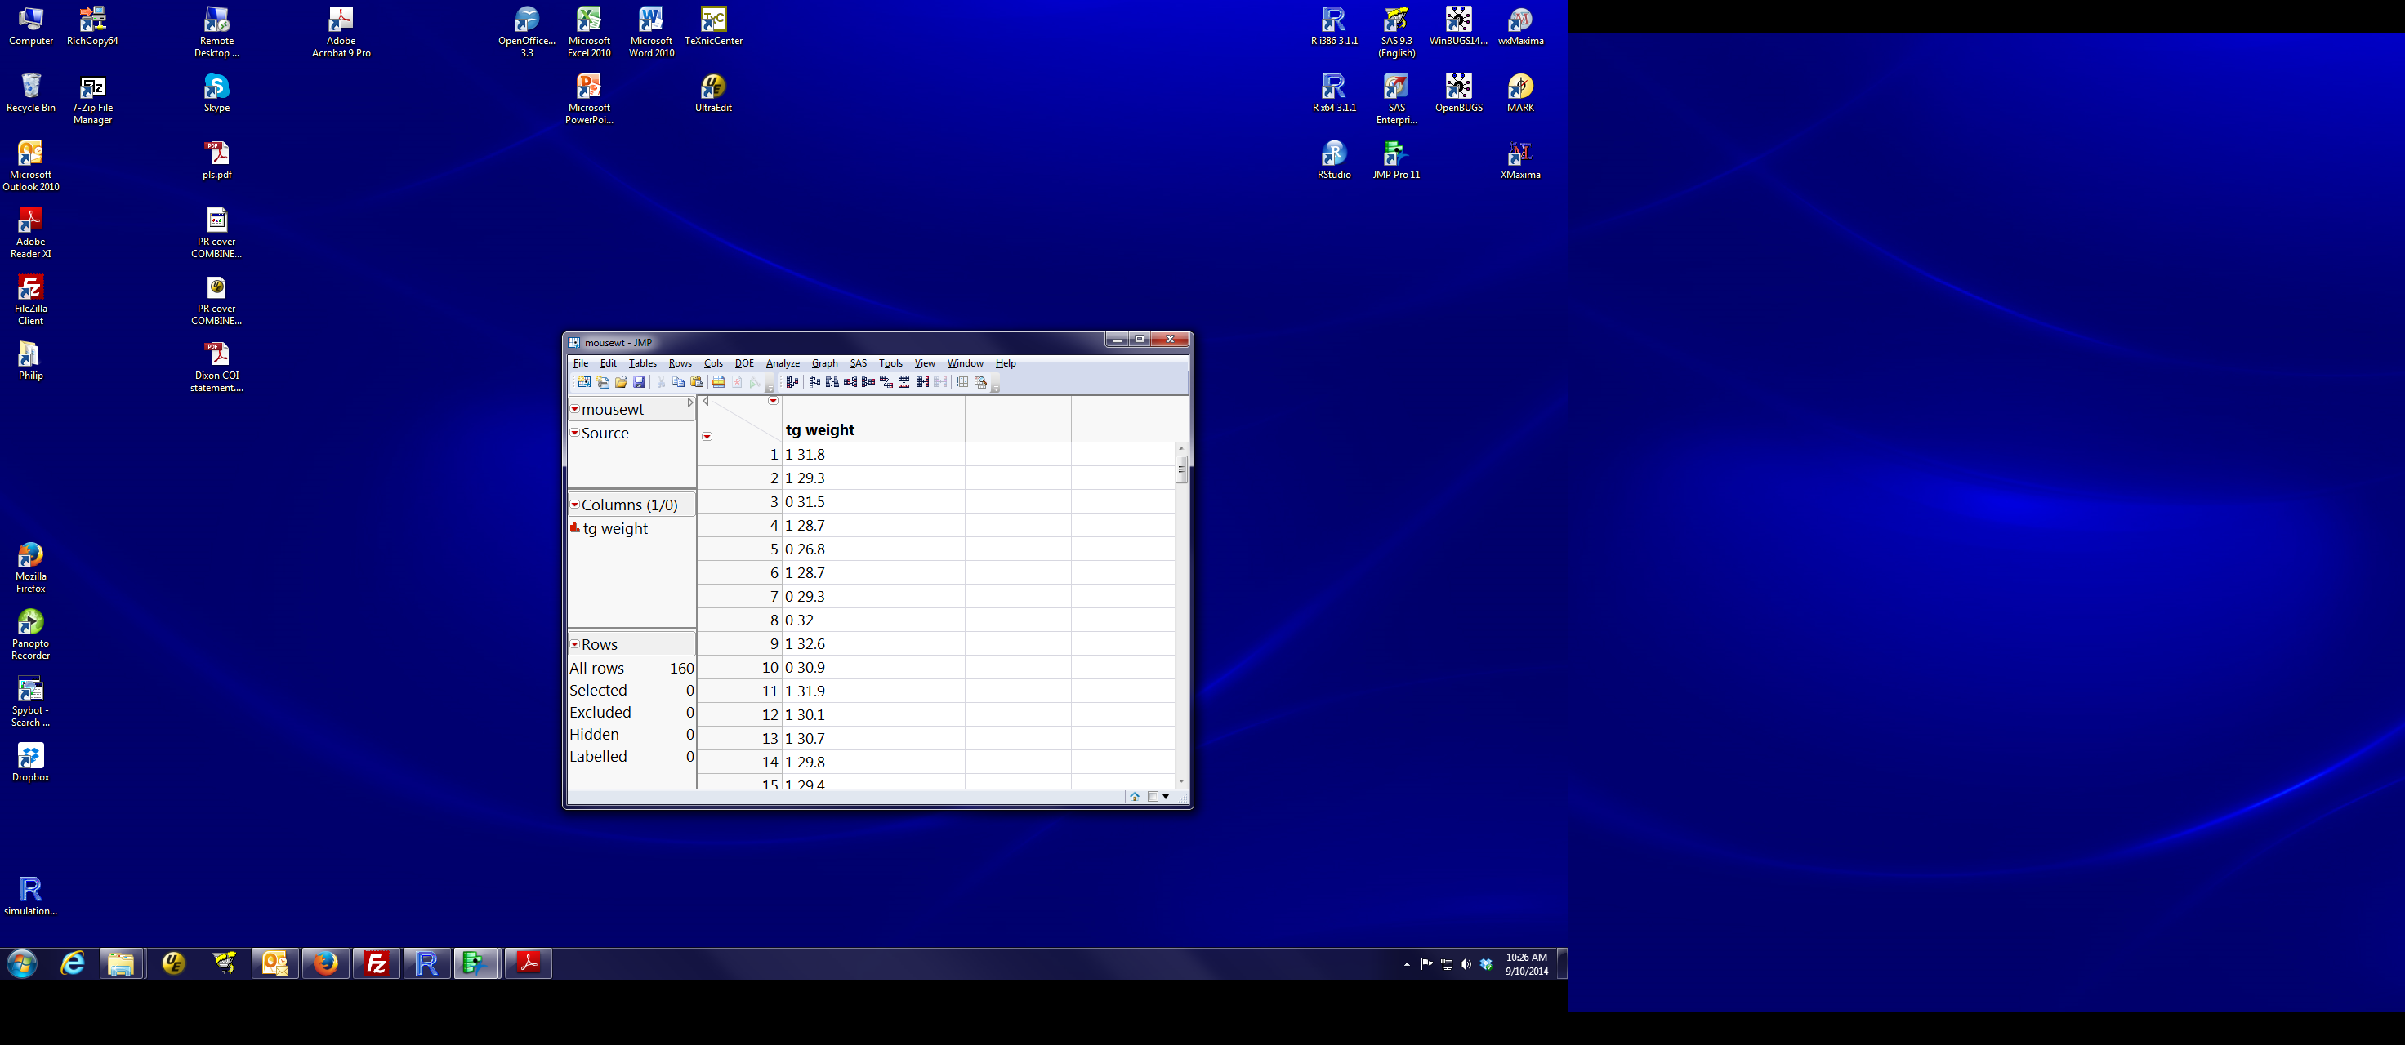
JMP read the file as containing one variable (i.e., one column of information) that is a categorical variable. There are two issues with the default read of the data file.
- The first is that JMP didn’t recognize that a space separates the tg value and the weight value.
The solution to this is to help JMP read the file properly. Close the mousewt window, then ask JMP to open the file again. This time, select the file (single click) and you will be given four options for how to read the file (see screen shot on next page). Click on the ‘Text, with preview’ button before clicking ok.
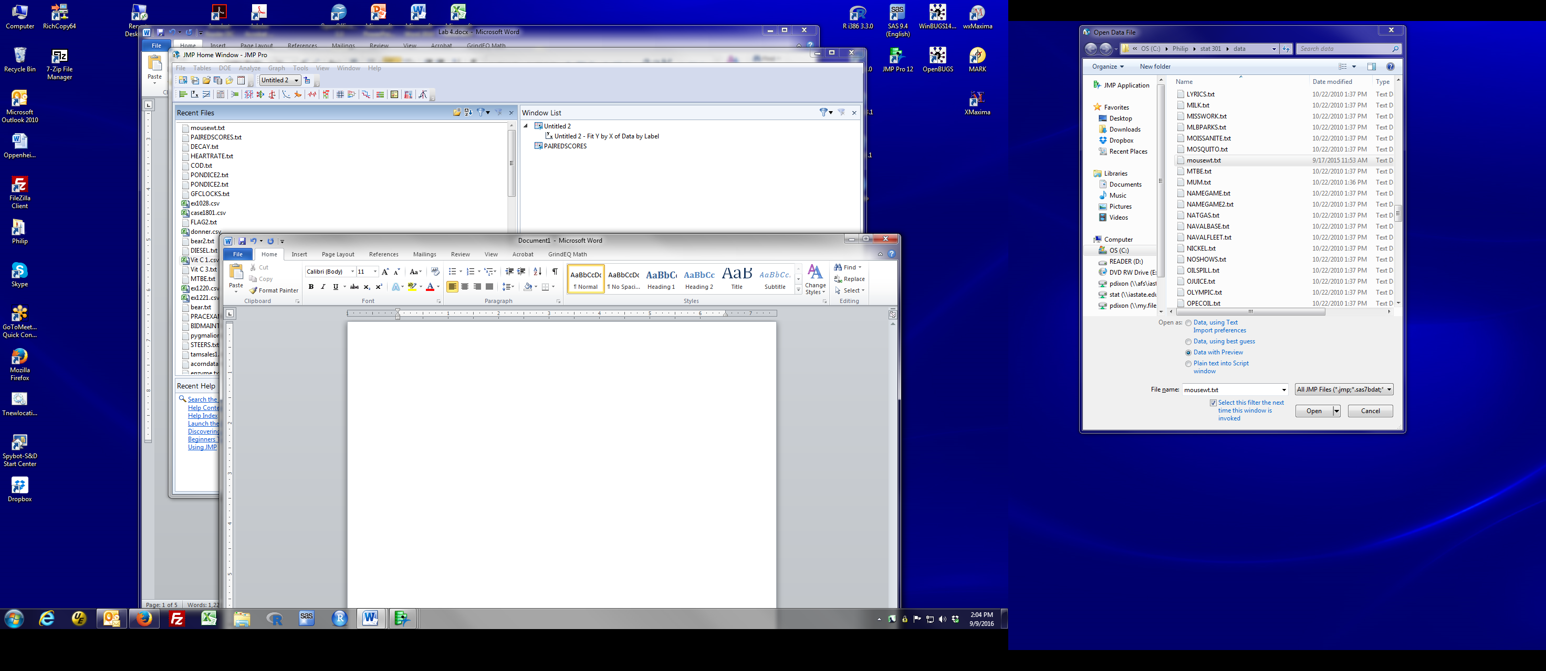
- A preview window will open. This gives you control over how JMP is to read the file.
The End of Field box specifies what character(s) separate fields on a line (i.e. separate tg from weight). To read the mousewt.txt file, space and spaces need to be checked.
The End of Line box specifies the characters that mark the end of the line.
A preview of the result appears in the top of the preview window (see next page). The vertical line separates fields that JMP will consider separate variables. In this case, the options in the preview window are sufficient to read each line as two fields. If you unclick the “Space” box in the end of field choices, you see that the vertical line disappears – JMP is now reading both variables as one field. Make sure that “Space” is active, so JMP will read two variables, then click Next.

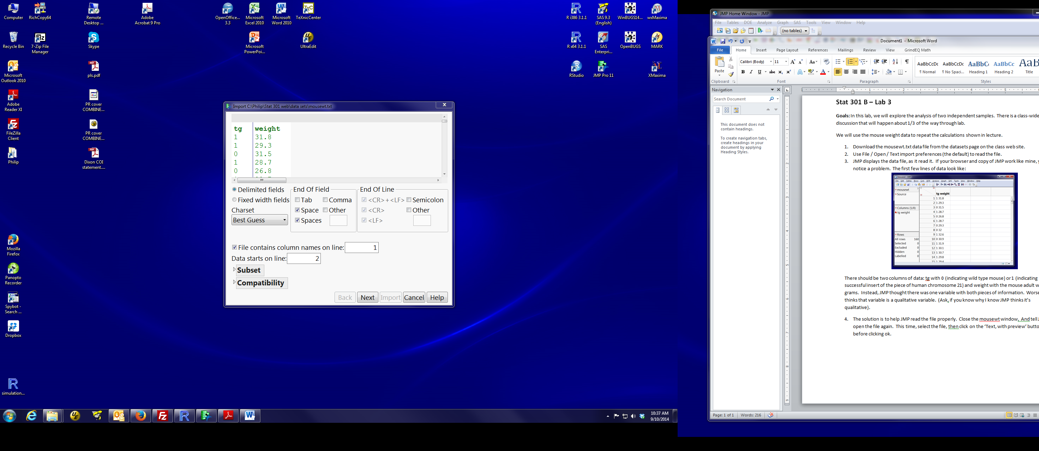

- The next dialog box provides options for changing how JMP interprets each field (as numbers, as character strings, or to exclude the column). We won’t need any of these in this class, so just click the Import button at the bottom of the dialog.
- The second issue with reading these data is that tg is a number, so JMP will treat it as a continuous variable, by default. We need it to indicate that defines groups (a nominal variable).
Remember from lab 2:
blue ramp is a quantitative variable; red bars are a qualitative variable.
We want tg to be a qualitative variable and weight to be a quantitative variable. To change tg:
left click on the blue ramp by tg in the columns box and change the data type to nominal OR
left click on tg, so select the variable, choose Cols / Column Info from the top menu bar and change the modeling type to nominal.
- You should have a new data table with two variables (i.e., two columns). tg is a red bars column; weight is a blue ramp column (see next page).
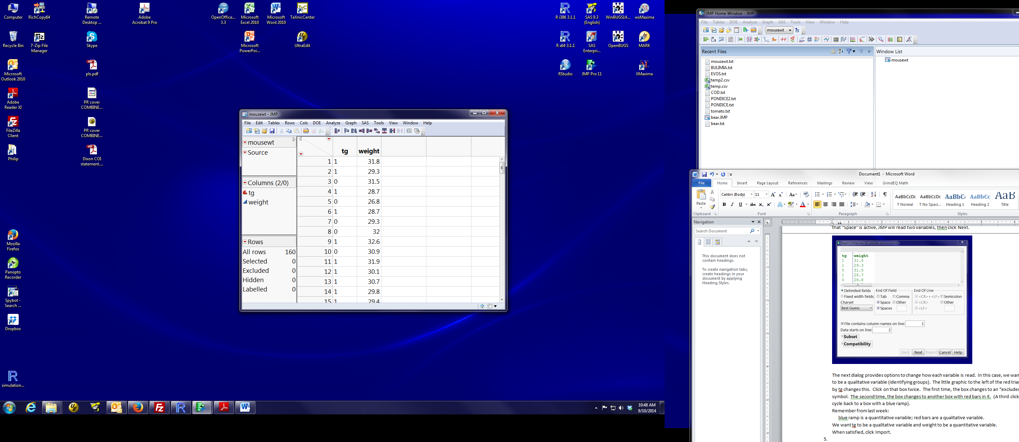
- To get descriptive plots and summary statistics for each group of mice separately, choose Analyze/Distribution from the main menu. Put weight into the Y, Columns box and tg into the By box. The dialog window should look like:
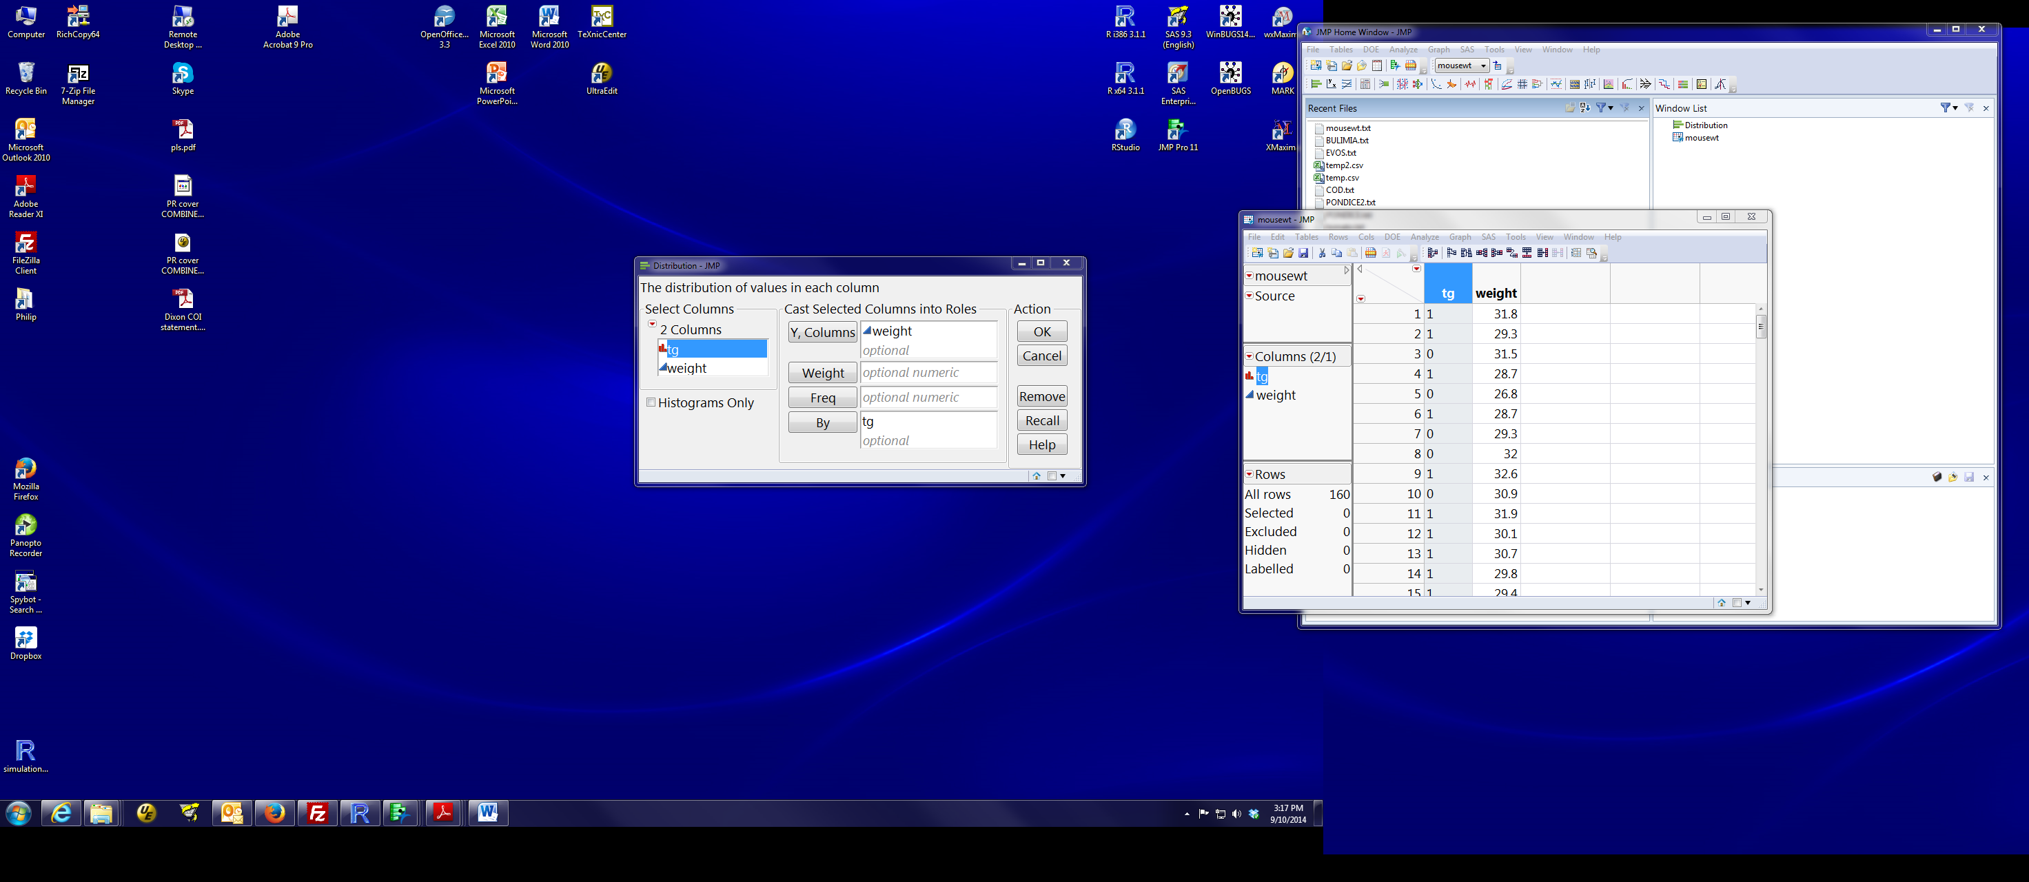
Then click OK. You will get a histogram, quantiles, and summary statistics just like last week, except now there is a block for observations with tg=0 (wild type mice) and block for observations with tg=1 (transgenic mice).

Two-sample t-test and related quantities (SE of difference, CI for difference):
We focus on the equal variance version, but show how to get the unequal variance if that’s wanted.

- To calculate the t-test and related quantities, choose Analyze/Fit Y by X from the main menu. Put weight into the Y, columns box and tg into the X, factor box. The dialog should look like:
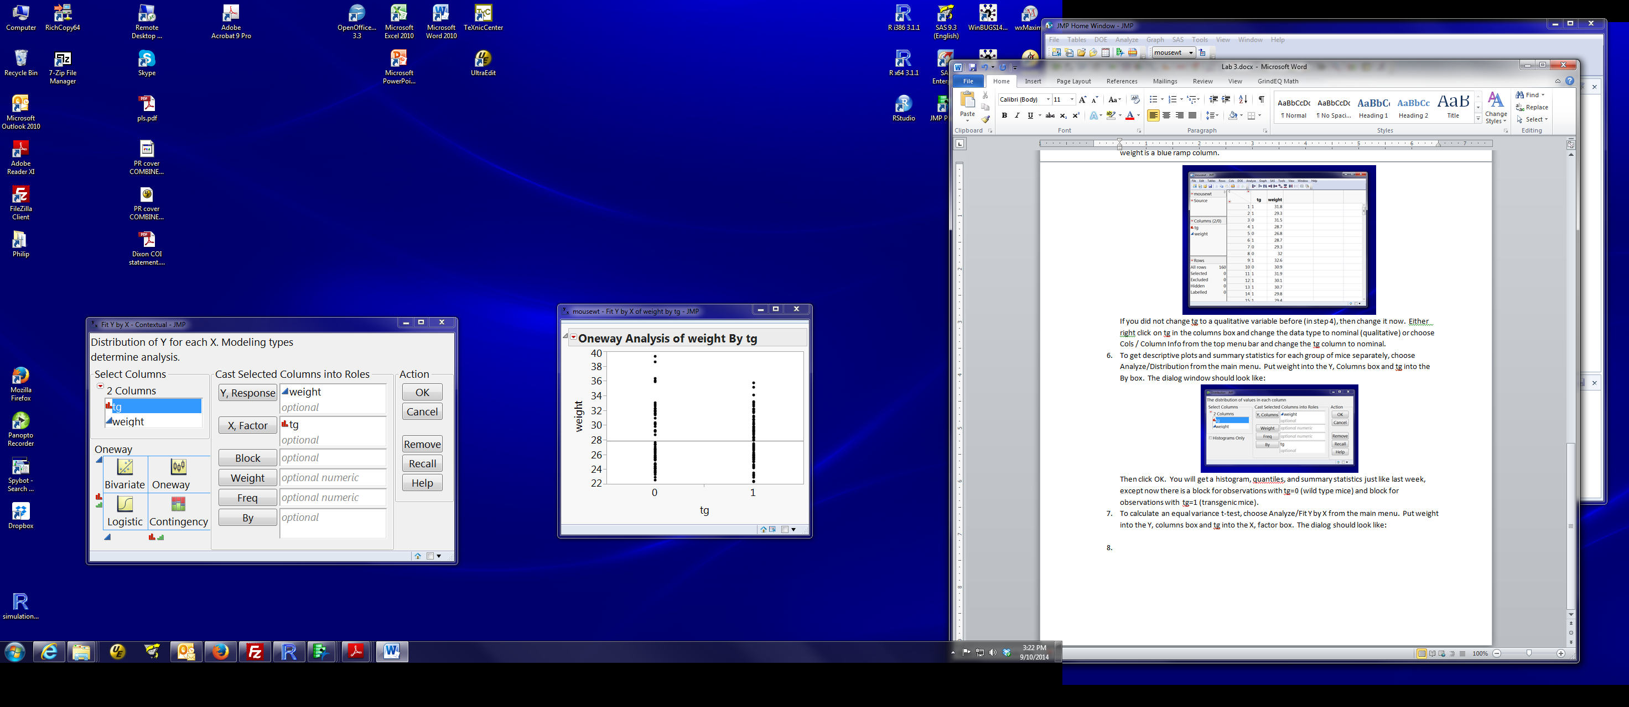
Then click OK.

- You will get a dot plot of the response variable (Y, weight) for each level of tg:
This works for any qualitative (nominal, red bar) variable as the X, factor variable. It would work just as well if the two levels of tg were “WT” and “TG”. Only difference is that the order of the groups across the X axis would be TG then WT (i.e., alphabetical).

- All the interesting stuff is obtained by clicking on the red triangle by Oneway analysis. The menu looks like:
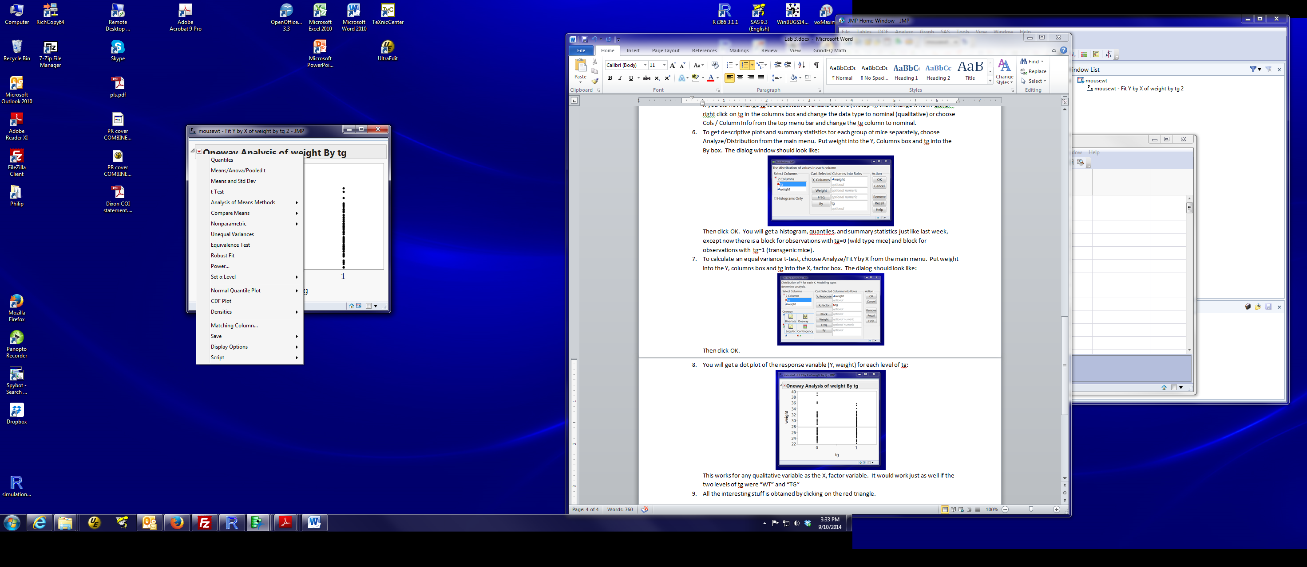

- To do the equal variance t-test, select Means / Anova / Pooled t.
This does the equal variance t-test. Look at the box labelled t Test. Ask if you can’t figure out how any of the results in that box are labelled. We will talk about the Analysis of Variance box later in the semester.
pooled standard deviation: this is in the output, but it isn’t obvious. It’s labeled “Root Mean Square Error” in the Summary of Fit box (the first box of results).

- The first, third and fourth choice on the menu could also be useful:
Quantiles: reports various quantiles and adds simple box plots to the graph. If you want the dots marking each point to disappear, the way I know to do that is to right-click on the graph, select transparency, then put 0 in the box. (Aside: since the dots overlap, setting transparency to 0.1 or 0.2 does nice things to the plot. Try and see).
Means and Std Dev: Adds a box with sample statistics for each group, and 95% confidence intervals for each mean. The standard errors (and hence confidence intervals) are based on the group-specific sd, not the pooled sd. The confidence level can be changed using the ‘Set alpha level’ option (12’th in the list).
T Test: Does the unequal variance t-test. Notice that the DF are not an integer. This is because the DF aren’t well defined and JMP uses an approximation. I generally don’t use this.

Various sections of JMP output give results from different methods (e.g., using group-specific variances = unequal variance method or using the pooled error variance = equal variance method) .
To summarize where to find results that you want:
Mean and sd for each group:
Means and Std Dev output

Pooling variances (i.e., equal variance version)
Pooled sd: In Oneway Anova/T test output, Root Mean Square Error in Summary of Fit box
Std error and CI’s for each mean: Oneway Anova/T test output, Means for Oneway Anova box
Estimate of difference, se and CI for difference: Oneway Anova/T test output, t Test box
p-value for two-sided test of no difference: Oneway Anova/T test output, t Test box, Prob > |t|

Not pooling variances (i.e., unequal variance version)
Std error and CI’s for each mean: In Means and Std Dev output
Estimate of difference, se and CI for difference: t test output / t Test box
p-value for two-sided test of no difference: t test output, t Test box, Prob > |t|

Paired t-test:
- Download the pairedscores.txt file and read it into JMP. The default read should work fine. The data set has three variables:
Pair (1, 2, … 8) indicating each unique pair of students
New: the score of the student receiving the new teaching method
Standard: the score of the student receiving the standard teaching method

- We demonstrate two different ways to get estimates, tests and confidence intervals for paired data. There are more, but these two should be sufficient. These are to compute the difference for each pair, then analyze the differences (the approach presented in lecture), or to use the JMP Analyze / Matched pairs platform .

- Explicitly computing the differences:
This approach computes a new variable containing the differences within each pair.
a) You can read the data set into Excel and use Excel to compute the difference.
JMP can read Excel files (.xlsx, .xls, or .csv) as well as many other file formats.
b) You can compute the difference in JMP by creating a new column and specifying a formula to compute the contents of that column. Here’s how:
Click on the paired scores data set window to make it active (highlighted).
Right click at the top of a blank column (e.g. to the right of STANDARD) and choose New Column
The dialog box allows you to specify the properties of this new column.
Type in an appropriate variable name in the Column Name box (e.g. Difference).
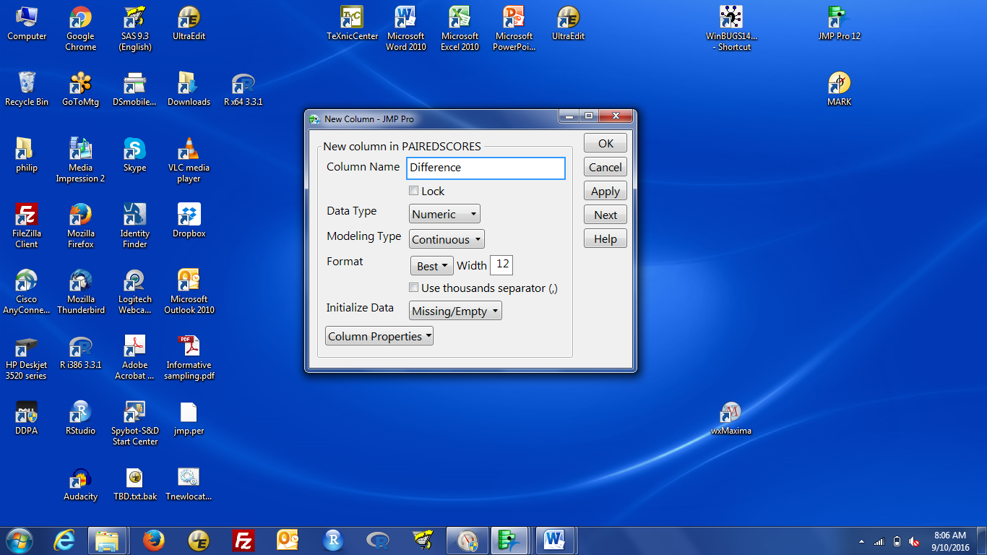
Left click on the Column Properties box (bottom right of the dialog). Select Formula.
You will get a formula dialog box that allows you to specify the contents of the new column.
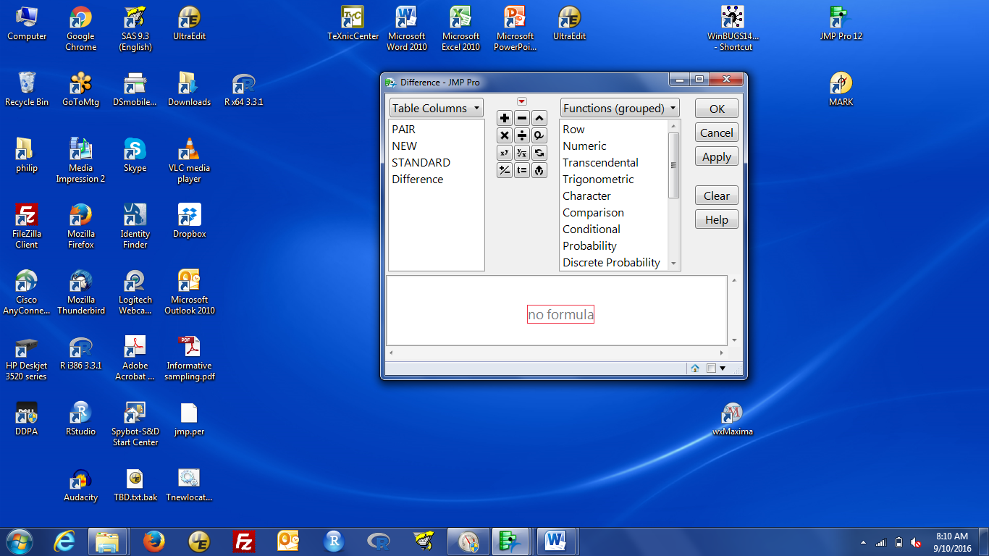
Use the mouse to define (by left-clicking) the quantity to be computed.
If the difference is NEW – STANDARD, you would:
left click on NEW
left click on – in the middle box of arithmetic operators
left click on STANDARD
The formula appears in the lower box. When ready to run, that dialog should look like:
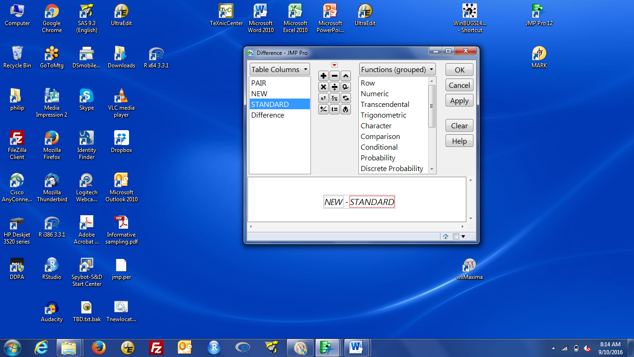
Click OK to calculate the new column. The data window now has a 4th column containing the differences.
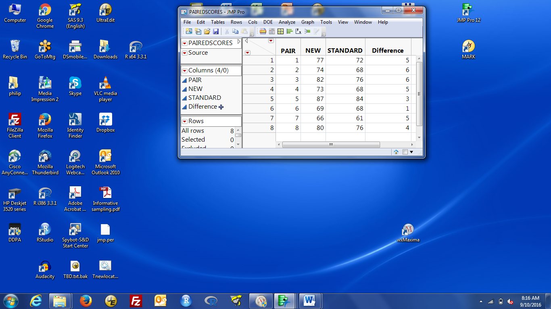

- Once you have a column with the differences (either through Excel or JMP), use Analyze / Distribution on the difference. You get the estimate, precision and confidence interval by default. You get the p-value by asking for a t-test of null difference = 0.

- Using the Matched Pairs platform:
You do not need to explicitly compute the difference – JMP will do this for you.

Click on the pairedscores data window to make it active, then select Analyze / Matched Pairs. You need to provide two variables containing the two parts of the paired data (in Y, Paired Response). The Matched Pair dialog should look like this:
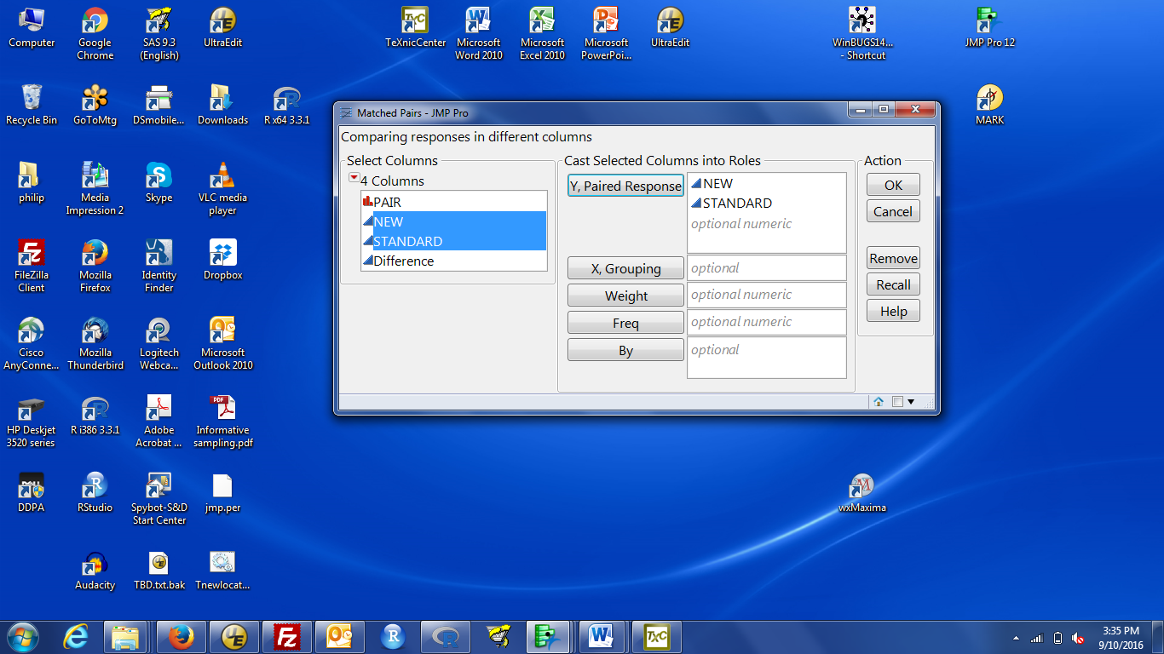
Then click OK to run the analysis.

- The output includes a plot of the difference (on the Y axis) against the average (on the X axis). This is known as a Bland-Altman or Tukey mean-difference plot. If you get various horizontal and diagonal lines on the plot, you can suppress them by clicking the red triangle by Matched Pairs and unclicking the Reference Lines option. Ask if you’re interested in this plot.

The numeric output below the plot includes the mean for the two groups, the estimated difference, the standard error of that difference, a 95% confidence interval for the difference, the sample size, and information about the test of difference = 0. The test information includes the t-statistic (called t-ratio) for the, the df, two-sided p-value (Prob > |t|). The output also includes the correlation between the two paired measurements.
Remember that you can get other confidence intervals using the Set alpha level option under the red triangle by Matched Pairs.
If you want results for the opposite subtraction (e.g., B-A instead of A-B), put B below A in the list of variables.
Self Assessment:
The Dietstudy.txt data set contains the weight loss under two diets. The data are measured as pounds lost. This is the two-sample example in the book. Using those data,
- What is the pooled sd?
- In these subjects, which diet had the larger weight loss? What is the estimated difference between diets?
- Using the pooled sd, what is a 95% confidence interval for the difference in weight loss (between the two diets)?
- Using the pooled sd, what is the p-value for the test of no effect of the diet on weight loss.
The schiz.txt file contains data on the hippocampus (part of the brain) volume in individuals with schizophrenia (affected) and not (unaffected). The units are cubic centimeters, cm³. The investigators who collected these data identified pairs of identical twins where one (and only one) member of the pair had schizophrenia.
- What is the estimated difference in hippocampus volume?
- What is a 95% confidence interval for the difference between the affected and unaffected individuals?
- How strong is the evidence of a difference between affected and unaffected individuals?
- Finding pairs of identical twins is somewhat difficult. Finding pairs where one is affected and the other is not is extremely difficult. Why might pairing be worth that effort in a study like this?
Answers:
- 4.36
- The lowfat diet. 1.9 pounds.
- (-3.13, -0.69)
- p = 0.0023
- - 0.20 cm³ (smaller in the affected individuals)
- (-0.067, -0.33) cm³
- very strong. p = 0.0061
- Identical twins have the same genetics. Genetics can influence hippocampus volume. If you looked at two unrelated samples (affected and unaffected), they may differ in genetics and you don’t know whether the observed difference is a consequence of schizophrenia or genetics or a bit of both. When you pair, you can rule out a difference in genetics. As we will discuss in lecture (coming up soon), matching is one way to strengthen conclusions from an observational study.

